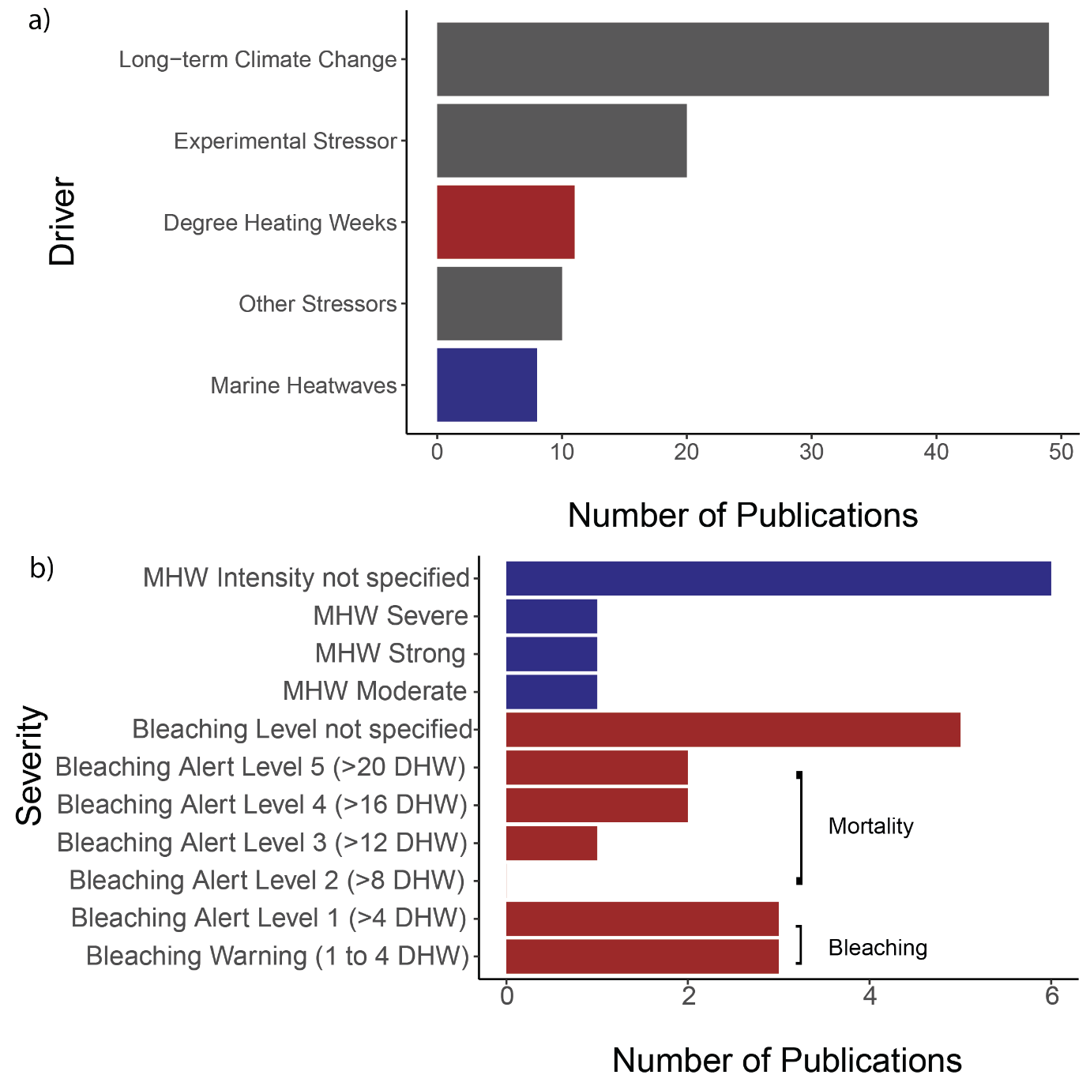

Figure 16 a) Drivers of extreme weather events recorded, including degree heating weeks (DHW) (Red) and marine heatwaves (MHW) (Blue). b) Number of publications reporting the seveity of DHW bleaching alerts and MHW severity (Hobday et al., 2016).